ComCept .Net Mobile Shop Training Documentation

Table of Contents

Introduction 3
Requirements 3
Disclaimer 3
Mobile Shop - Application Launch 4
Mobile Shop - Account Creation 4
Mobile Shop - Login 5
Mobile Shop – Feature (Main) Menu 6
Feature (Main Menu) - File Menu Item 7
Feature (Main) Menu - File Menu - Settings Menu 7
Feature (Main) Menu - Data Menu Item 9
Feature (Main) Menu - Data Menu – Get New 10
Feature (Main) Menu -Data Menu – Refresh 10
Feature (Main) Menu - Data Menu – Send 11
Mobile Shop – Replenishment 11
Mobile Shop - Replenishment Information Fields 12
Replenishment – Item List 12
Replenishment Menu Bar Item - Done 13
Replenishment Menu Bar Item - Actions 13
Replenishment – Item Details Menu 14
Replenishment – Manual Item Entry 16
Misc- Mobile Shop Outline 17

Introduction

ComCept .NET’s Mobile Shop Replenishment application is designed to assist shops in tracking inventory quantities.

Requirements

Operating System
Pocket PC 2003 | No
Windows Mobile 5.0 | Yes
Windows Mobile 6.0 | Yes
Windows Mobile 6.5 | Yes
Memory
Program | 17 MB
Storage | 2 MB / Company
Screen Size
240 x 320 | Yes
Dependencies
Compact Framework | v2.0+
SQL Server Compact | v3.5

Disclaimer
This document is for reference purposes only. All images used in this Training Document were created using an emulated virtual device and may not resemble your mobile device of choice in part or in whole. Please contact ComCept Support if you have concerns or questions about which Mobile Device to use for Mobile Shop.

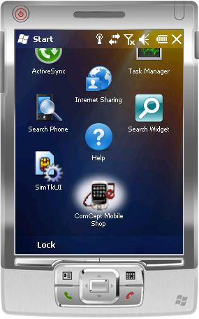Mobile Shop - Application Launch

To launch the ComCept Mobile Shop application simply tap the applications icon from the program window of your mobile device.

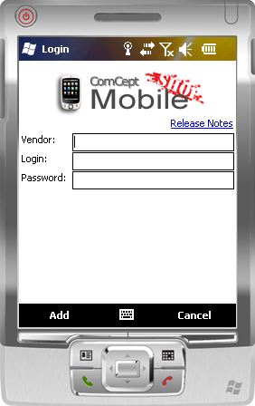

Mobile Shop - Account Creation

Once the Mobile Shop application is launched a login screen will be displayed.
Mobile Shop will require you to Add your account the first time you launch the application.
You will need to enter the code your Vender has provided for you to use in the Vender field.
You will also need to enter the Login and Password that your vender has issued to you.
Once you have entered your information simply tap the Add Item.
If you do not have a keyboard to enter information use the Soft Input Panel

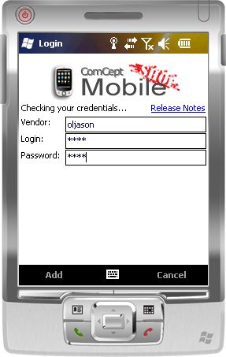Mobile Shop - Login

Once you have tapped Add, the Mobile Shop application will verify the information you have entered before allowing you to login.

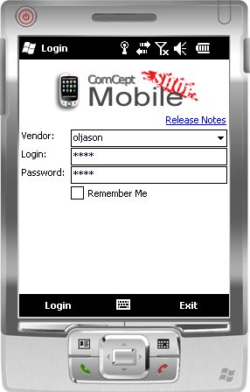

Once your account has been verified and a vender database created on the device you will be ready to Login to the Mobile Shop application.
If you wish to add another account, the drop down in the Vender field will let you Add a new account to the Mobile Shop application.
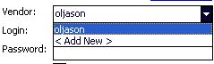
Otherwise simply tap Login to begin using the Mobile Shop application.

Mobile Shop – Feature (Main) Menu

Upon completion of the login process you will arrive at the Feature (Main) Menu for the Mobile Shop Application. During the first initial seconds upon loading the screen, the software will check for any new software updates.
The software displays in the text window when it is syncing data, or checking for software updates.
Also the Data Sync Indicator in the right hand corner will also show when the application is in the process of syncing.

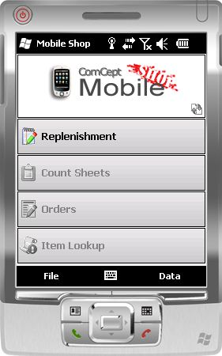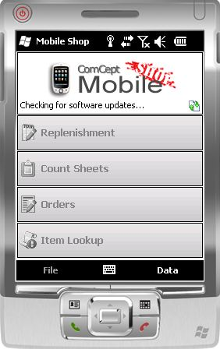

From the Feature (Main) Menu in Mobile Shop you can access the different features available within the application.
At this time only Replenishment is currently active.
The Count Sheets, Orders, and Item Lookup features are in development at this time.
At the bottom of the Feature (Main) Menu screen is the Feature Menu Control Bar Items, File and Data.

Feature (Main Menu) - File Menu Item

The File Menu Item when tapped will bring up the File Menu. The 3 options here are: Exit, Logout, and Settings.
Exit will exit the application.
Logout will log you out and bring you back to the Login screen.
Settings will open the Settings Menu where you can make adjustments to the application.

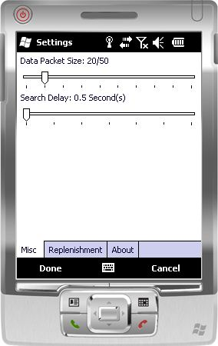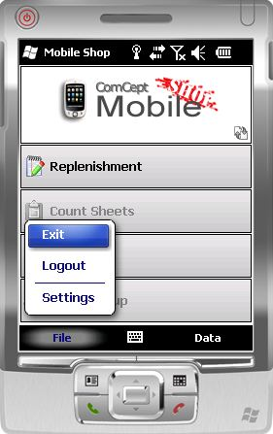

Feature (Main) Menu - File Menu - Settings Menu

The Settings Menu has 3 separate menu tabs these are: Misc, Replenishment, and About.
At the bottom of the Settings Menu are the 2 Settings Menu Control Bar Items, Done and Cancel.
Done when tapped will save any adjustments you have made and return you to the Mobile Shop Feature (Main) Menu.
Cancel when tapped will discard any changes made and return you to the Mobile Shop Feature (Main) Menu.

Feature (Main) Menu - File Menu - Settings Menu – Misc Tab

The Misc Tab is where you can adjust the Data Packet Size and the Search Delay values.
The Data Packet Size by default is 20/50. However it has a min/max range of 10/25 to 100/250. This option allows you to set the upload/download packet sizes for optimum performance.
The Search Delay time by default is 0.5 seconds. However it has a min/max range of 0.5 to 2.0 seconds. This option allows you to set the time delay that will occur from when you enter the first character in a manual item search to when the application will begin to search based on the last character entered.
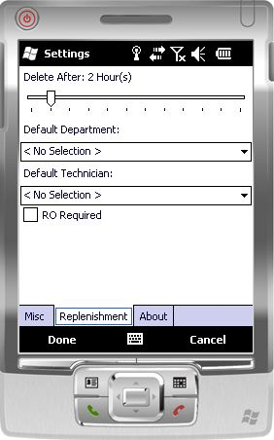

Feature (Main) Menu - File Menu Item - Settings Menu – Replenishment Tab

The Replenishment tab is where you can adjust the Delete After, Default Department and Default Technician values. RO Required is in development.
Delete After is where you can set the time period in which old data that has already been uploaded is deleted. By default it is set to two (2) hours, but has a min/max of from one (1) to twelve (12) hours.
Default Department is where you can specify a particular department. The default is No Selection.
Default Technician is where you can specify a particular technician. The default is No Selection.

Feature (Main) Menu - File Menu - Settings Menu – About Tab

The About tab dsiplays current information about Mobile Shop and the device.
From here you can also manually check for software updates by tapping the Check For Updates Item.

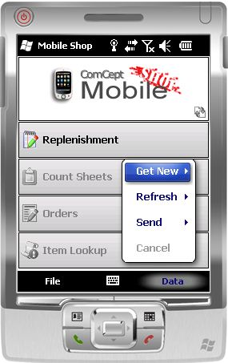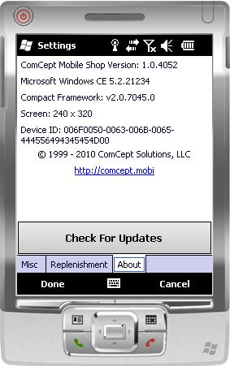

Feature (Main) Menu - Data Menu Item

The Data Menu Item when tapped will bring up the Data Menu. The 4 options here are: Get New, Refresh, Send and Cancel.
Cancel when tapped will stop the data sync process and close the Data Menu, returning you to the Mobile Shop Feature (Main) Menu.

Feature (Main) Menu - Data Menu – Get New

Get New will open up the Get New sub menu. From the sub menu you can choose to get new data for each of the individual items in the menu or for all of the items in the menu.

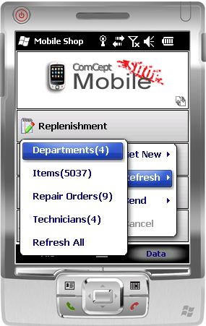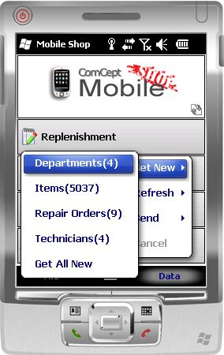

Feature (Main) Menu -Data Menu – Refresh

Refresh will open up the Refresh sub menu. From the sub menu you can choose to Refresh data for each of the individual items in the menu or for all of the items in the menu

Feature (Main) Menu - Data Menu – Send

Send will open up the Send sub menu. From the sub menu you can choose to tap Replenish.
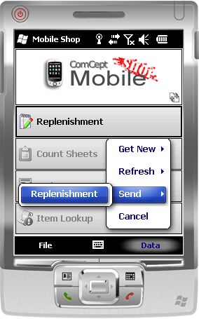This will update any open orders that match the replenishment item criteria or create a new order if no order matches the criteria.

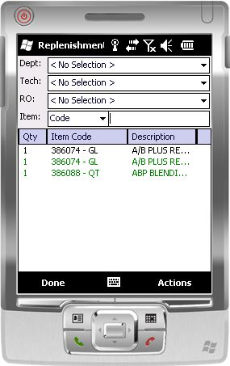

Mobile Shop – Replenishment

From the Mobile Shop Feature (Main) Menu tapping on Replenishment will open the Replenishment Menu screen.
This is the screen where you will make your entries for items you use from your shop’s inventory.
This screen has the following entry fields : Dept, Tech, RO and Item.
The Item List dialog box is where the Qty, Item Code and Description are displayed.
At the bottom of the Replenishment Menu screen is the Replenishment Menu Control Bar Items, File and Data.

Mobile Shop - Replenishment Information Fields

Dept. is the Ship To field. This can be populated by either scanning in the UPC\Barcode for the Dept, or by choosing it from the drop down menu.
Tech. is the technician working on the order. This can be populated by either scanning in the UPC\Barcode for the Tech, or by choosing the Tech from the drop down menu.
RO is currently not available.
Item is the field where you enter in the item being used. This can be populated by either scanning in the UPC\Barcode for the Item, or by manually entering either the items part number or its description.

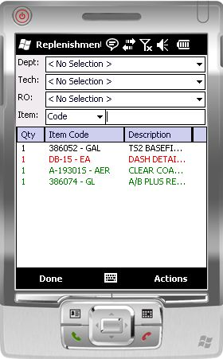Replenishment – Item List

Item List is where the Qty, Item Code, and Item Description are displayed.
Items entered here are colored coded. Items whose text is Black are items that have not been added to an OrderLinx order and can have their quantities modified. Items in Green have been added to an Orderlinx and cannot be edited from here. Items in Red indicate that either an error has occurred in sending, or that the item may not be availiable for sale.

Replenishment Menu Bar Item - Done

The menu bar item Done when tapped will save the current state of the items you have entered and return you to the Mobile Shop Feature (Main) Menu. This will not synch the items to the open order.

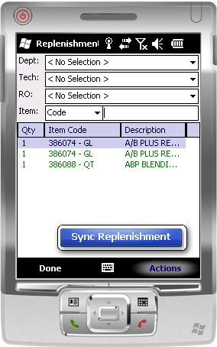

Replenishment Menu Bar Item - Actions

The menu bar item Actions when tapped will open a context menu. From the context menu you can tap the Sync Replenishment Menu Item. Tapping this will update any open orders that match the replenishment item criteria or create a new order if no open order matches the criteria.

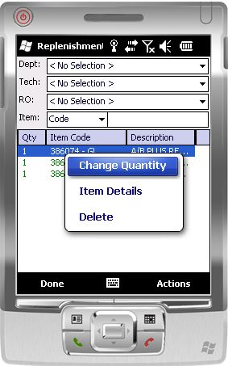Replenishment – Item Details Menu

To open the Item Details Menu, simply tap and hold on an item that you wish to view \ edit.
From the Item Details Menu you have 3 options : Change Quantity, Item Details and Delete.
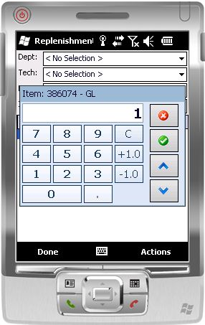

Replenishment – Item Details Menu – Change Quantity

The Change Quantity Menu Item will open up the Calculator feature. From here you can adjust the quantity of the item that you originally tapped.
Shortcut : If all you wish to do is adjust the quantity of an item and want to bypass the Item Details Menu, then just tap the item you wish to adjust and the Calculator feature will open..
Note: If the Item is in Green, you cannot adjust that items quantity.

Replenishment – Item Details Menu Item – Item Details

The Item Details Menu Item will open up the Item Details Context Menu. From here you can view information about the Item entered.
If you are veiwing an Item that has already been sent then the Details Dialog Box will also include the Orderlinx order number that the Item has been assigned to.
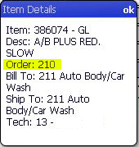

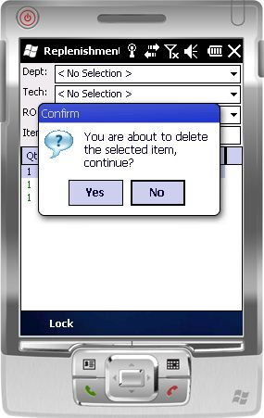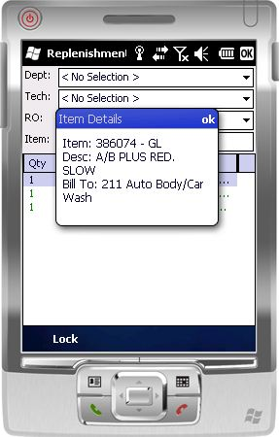

Replenishment – Item Details Menu Item –Delete

The Delete Menu Item will open up the Delete Confirmation Menu. From here you simply choose whether or not you wish to Delete the item from the list.

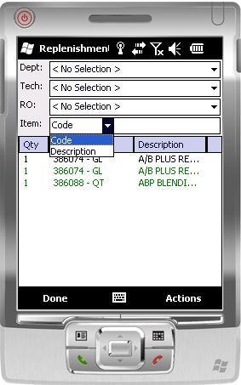Replenishment – Manual Item Entry

By default the Item field will be set to search for an item by the Item’s Code. However, you can choose to search by an Item’s Description by choosing Description from the drop down menu.

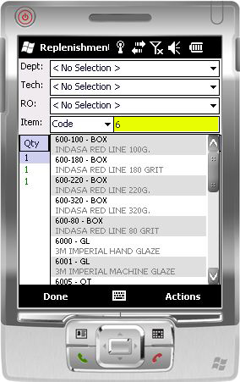

The box highligted in yellow is where you enter either the Item Code or Item Description. Mobile Shop will then provide a list of all Items that come closest to matching the data you have entered. Once you find your Item, then tap it and it will be added to the other items in the Item List.

Misc- Mobile Shop Outline

Mobile Shop
Application Launch
Account Creation
Login
Feature (Main) Menu
File Menu Item
Exit
Logout
Settings
Misc
Change Data Packet Size
Change Search Delay
Replenishment
Change Delete After
Change Default Dept
Change Default Tech
R.O Required
About
Check for Updates
Data Menu Item
Get New
Get all New Departments, Items
Refresh Repair Orders, Technicians
Refresh All
Send
Replenishment
Cancel
Replenishment
Dept
Tech
R.O
Item
Code
Description
Item List
Qty
Item Code
Item Description
Item Details Menu
Change Quantity
Calculator
Item Details
Delete
Manual Item Entry

Count Sheets
Orders
Item Lookup

